

Analysis of Gyms and Sporting venues' distribution across Toronto

**Salaheldin Gaffar**

Data Scientist

# Introduction

### Description and Background

During the 2020 COVID-19 pandemic, several issues in the health of the world population were not only unveiled but in fact emphasized. As of today, October 24th 2020, 1.1 million people have died all over the world out of 42 million reported cases, which gives the virus approximately a 2.6% death rate. Out of these 42 million cases and 1.1 million deaths, 200 thousand cases and 9862 deaths occurred in Canada, which shows an alarmingly elevated death rate of around 4.9%.

The higher than global death rate in Canada can be explained through numerous studies that have been conducted to correlate the death rate with age, race, gender and demographic, overall health status, access to quality healthcare. These studies have been supplied with plenty of data has been collected throughout the past 10 months, a feature that was not available to the previous generations that witnessed the 1918 Spanish flu pandemic.

It has been proven that there was a significant disparity between the death rates of upper-class and lower-class individuals, which can be explainable through several factors including: diet and exercise habit differences, pre-existing condition occurrences, nature of work and feasibility of working from home and several other factors. The image below represents one of these factors, as per Gallup’s poll conducted in the USA; the plot shows the incidence of pre-existing conditions across different income divisions.

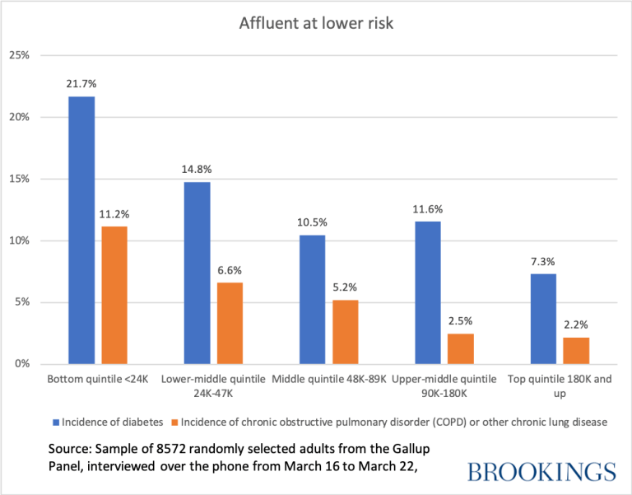

It is no secret that obesity is strongly correlated to both presented pre-existing conditions and Canada places 44th out 190 countries in terms of overall mean BMI scores (refer to WHO data at 2014) with an average BMI of 27.2 (above 25.0 is overweight). It is also worth-mentioning that Canada ranks 26th in BMI in males with an average BMI of 26.

For the reasons stated above, Canadian authorities as well as several other organizations such as **Obésité Canada** (OC) are very interested in the reasons behind this increased obesity levels. Several nutrition related initiatives have been in execution for the past 10 years and will continue in the future. However, the second part of the health equation, exercise will the focus of this study.

In particular, the focus of the study will be concerning the availability of gym and other sporting venues for the citizen of Toronto, Canada. The map below shows the registered sporting venues in Toronto and their distribution. It is required to understand whether the distribution below is in fact correlated to the population count for each neighborhood, or whether sporting facilities are poorly distributed and more governmental and NGO incentives should be offered to gyms and their equivalents to open in the less-served neighborhoods.

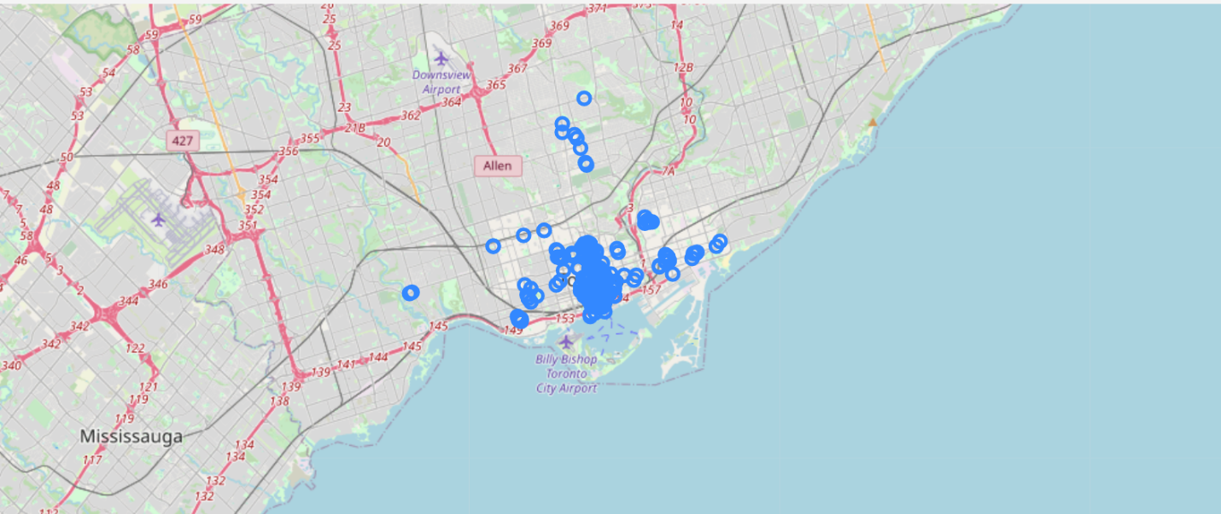

# Target reader for report

This report should prove to be beneficial for several entities; it should serve **government officials** in Toronto identify regions where more work should be done in providing sporting facilities for citizens.

Moreover, charitable and other civil society organizations can benefit from identifying regions where sporting facilities are lacking. Finally, businesses that are looking for attractive locations to open gyms, where there are plenty of target customers can find guidance in this report that can help them with their market research.